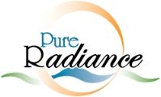

Laser Hair Removal Aftercare Instructions

After Your LHR:

- Avoid sun exposure to treated area as much as possible for 5 days after treatment.
- Apply 30 SPF mineral sunblock to treated area for 5 days after treatment.
- No shaving or exfoliating to for 3 days or until sensitivity subsides.
- Use gentle cleansing products free or fragrances or harsh chemicals.
- After 3 days, begin exfoliating to remove post- lasered hair.
- Do not pick or scratch treated area.
- Return for your next treatment: ________________________

Print Name____________________________DOB____________________Date_____________________

For any questions or concerns, please feel free to contact our office at (903) 561-0300.

